WEBSITE PROJECT PROPOSAL
Coffee Emporium
Name: Musa
Surname: Cindi
Student Number: ST10502886
Module Code: WEDE5020

Table of Contents
1. Organization Overview
2. Website Goals and Objectives
3. Current Website Analysis
4. Proposed Website Features and Functionality
5. Design and User Experience
6. Technical Requirements
7. Timeline and Milestones
8. Budget
9. References

1. Organization Overview
Coffee Emporium is a fictional coffee company based in Braamfontein, Johannesburg. The business aims to provide quality coffee, light meals and a comfortable environment for students, young professionals and residents. Its mission is to provide affordable, quality coffee and a welcome customer experience. Its vision is to become a popular local coffee destination in Braamfontein. The website will help the business build an online presence and make information about its products and services easier to access.

2. Website Goals and Objectives
The main goal of the website is to create a professional online presence for Coffee Emporium and make it easier for customers to discover the business. The website should display the menu, provide contact and location information, promote special offers and encourage customers to visit.
- Increase awareness of Coffee Emporium online.
- Make the menu and business information easy to find.
- Encourage customer enquiries and visits.
- Promote new products and special offers.

3. Current Website Analysis
As this proposal is for a fictional client, there is no existing website to analyses. The proposed website will address the needs of a small coffee business by providing a clear and mobile-friendly design, simple navigation and easily accessible business information.

4. Proposed Website Features and Functionality
- Homepage – introduce Coffee Emporium and highlight popular products or promotions.
- About Us – provide information about the business and its values.
- Menu – display coffee, drinks, snacks and other available products.
- Gallery – show the coffee shop, products and atmosphere.
- Contact – provide contact details, opening hours and location information.
- Promotions – advertise specials and seasonal offers.

5. Design and User Experience
The website will use a warm and modern coffee-shop aesthetic. The proposed color palette will include dark brown, cream and a muted green to create a welcoming feel. Aptos will be used for general text, with larger bold headings to create a clear hierarchy. The layout will be clean, with a navigation bar at the top and clearly separated sections. The design will also be responsive so that customers can use the website comfortably on phones, tablets and computers.
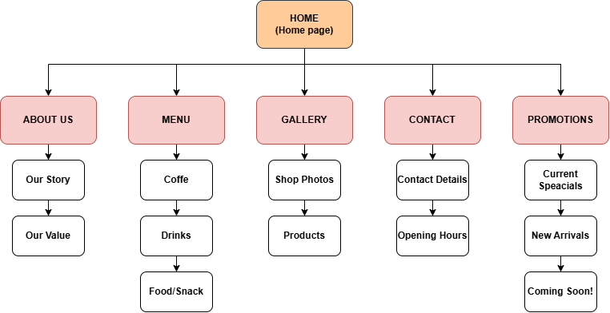

6. Technical Requirements
The website will require a domain name and web hosting. HTML will be used for the structure, CSS for styling and JavaScript for interactive functionality. The website should be responsive and tested on common desktop and mobile screen sizes.

7. Timeline and Milestones
- Week 1: Research, requirements and planning.
- Week 2: Wireframes and website structure.
- Week 3: HTML and CSS development.
- Week 4: JavaScript functionality and content.
- Week 5: Testing, corrections and final improvements.

8. Budget
A realistic, estimated budget for the project is R3,500. This includes approximately R800 for domain and hosting costs, R2,000 for development and R700 for ongoing maintenance and minor updates. The final cost may change depending on the hosting provider and additional features requested by the client.

9. References

